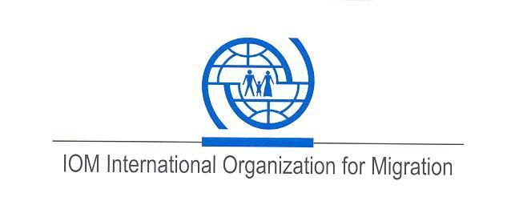

Terms of Reference (ToR)
Forum Theatre Plays as part of the Safe Migration Awareness Campaign

Nature of the Service:
The service intends to perform 32 forum theater plays to the general public in Anuradhapura, Kurunegala, Hambanota and Matara to carry the Safe Migration Campaign message. This initiative is part of the ongoing safe migration awareness campaign which is conducted throughout the country to spread awareness on the risks and disadvantages of irregular migration and the benefits of safe and regular migration.

Background about the Project:
The IOM Sri Lanka is engaged in a campaign to raise awareness among the vulnerable communities in irregular migration prone areas in Sri Lanka. Irregular migration has been a long-standing issue in Sri Lanka. However, it recently gained particular attention due to the surge of irregular migrants headed to Australia on boats and a high number of stranded migrants in West Africa on their way to Canada and Western Europe. So far IOM Sri Lanka has assisted more than 600 Sri Lankans who got stranded in transit countries like Guinea, Togo and Benin in conditions which pose a serious threat to their health and well-being.

The initiative therefore aims to raise awareness of the risks and disadvantages of irregular migration from Sri Lanka. IOM engages in the development and implementation of an information and awareness-raising campaign in the most-affected provinces, particularly in the North, East, West and Southern parts of the country. IOM also conducts targeted awareness programmes among the communities which are vulnerable to irregular migration.

- Purpose of the Service:

To raise awareness on safe migration through theatre forum plays. The audience are encouraged to participate in the forum which will enable them to imprint or reflect the safe migration message.

- Scope of the work:

Responsibilities of IOM

(i.) IOM will select the most suitable Divisional Secretariat Division in the district to perform the play and will communicate the same in advance with the service provider.
(ii.) IOM will monitor each show and provide feedback to improve performances as appropriate.
(iii.)The Safe Migration Campaign (SMC) banner and leaflets will be provided to the service provider’s artists for dissemination to the public.
(iv.) Orient the artists on the safe migration campaign message before the shows are performed.
(iv.) IOM staff will be sent to monitor the above shows performed by the service provider. The expenses of the IOM monitoring staff will be borne by IOM.

Responsibilities of the service provider

- The service provider will be responsible for conducting and completing 32 forum theatre plays in the given districts.
- Shows will be performed in Anuradhapura (8 shows), Kurunegala (8 shows), Matara (8 shows) and Hambantota (8 shows) districts.
- The content of the play will be developed by The service provider in collaboration with the IOM SMC team. The service provider will base their performances on the content approved by IOM.
- 32 shows will be conducted within a period of 9 weeks between the period stipulated above. There will be 2 shows a day which includes morning and late afternoon plays.
- The service provider is responsible for the duration of each play which will be minimum of 2.5 hours, morning shows will be performed for school students above the age of 15 or public while the evening shows will be performed for the public.
- Artists will be selected by the service provider suiting to the culture and language.
- The service provider will be responsible for accommodation and logistics of their staff/actors.
- Distribute the SMC leaflets to the audience and display the IOM SMC banner during each forum theater show mentioned within the aforesaid time period. The IOM banner should be returned to IOM Colombo office after the completion of 32 shows.
- The service provider will be responsible to gather the students and the public for the shows through their own mobilizing channels.
- The service provider is responsible for organizing the venues in the aforesaid districts.
- The service provider hall inform the performing dates and venues to IOM at least 5 working days in advance.
- The service provider shall provide a report for each district which should include the below details supported with videos and high definition photos in a DVD. Videos and pics should be provided for all 32 performances.
- Date and location
- Total audience count with gender breakdown
- No of interventions made by the audience
- Descriptive narration of the event
- Inquiries from the audience on safe migration
- A final report covering the shows in all 4 four districts

- Deliverables, Places and Timeline:

The programs will be held on the mutually agreed dates within the stipulated time period. The dates and locations shall be informed by the service provider to IOM in writing (via email) at least 5 working days prior to the commencement of shows in each district.

- Language Requirements

Sinhala will be the communication medium as the plays will be performed in predominantly Sinhala speaking areas.
- Payment to the Service:

Payment terms can be discussed in the Prebid meeting and IOM preferred to have credit facility . The payment will be made in line with clause no 4 of the service agreement. (Templete of the service agreement will share with you with request for proposal (RFP).

